K.Shamela
Mini-Project -2
Project Title : Luxury Housing Sales Analysis – Bengaluru
Course : Data science
Batch : DS-C-WD-E-B144

LUXURY HOUSING SALES ANALYSIS – BENGALURU

Problem Statement:
Build a complete real estate analytics solution using Python for advanced data cleaning, load the refined dataset into a SQL database, and use Power BI to directly connect to SQL and build a dashboard. The goal is to replicate a real-world enterprise-level data pipeline and analysis environment using a complex housing dataset with 1,00,000+ records.
Introduction
The real estate industry generates large volumes of transactional and market data. Analyzing this data helps developers understand buyer preferences, booking trends, and market demand.
This project focuses on analyzing luxury housing data to uncover trends related to builder performance, booking conversion rates, amenity impact, and market distribution.
The objective of this project is to build a complete data analytics pipeline that processes raw data, stores it in a structured database, and visualizes insights through an interactive dashboard.
The project integrates three major tools:
- Python for data preprocessing and feature engineering
- MySQL for data storage and querying
- Microsoft Power BI Desktop for interactive dashboard visualization
Project Workflow
The project follows a structured data analytics pipeline consisting of the following stages:
Data Pipeline Workflow:
Raw Dataset (CSV File)
→ Data Loading using Python (Pandas)
→ Data Cleaning (Handling Null Values, Removing Unnecessary Columns)
→ Feature Engineering (Creating Amenity Score, Booking Conversion Rate, Quarter Column)
→ Data Encoding (Label Encoding & One-Hot Encoding for Categorical Columns)
→ Data Validation and Preparation
→ Loading Processed Data into MySQL Database
→ Creating Database Tables with Primary Keys
→ Running SQL Queries for Aggregations and Analysis
→ Connecting Power BI to MySQL Database
→ Creating Interactive Dashboards and Visualizations
→ Generating Business Insights and Final Report
Data Collection:
Link : DATASET

The dataset contains information about luxury housing projects including Property_ID,Micro_Market,Project_Name,Developer_Name,Unit_Size_Sqft, Configuration, Ticket_Price_Cr, Transaction_Type, Buyer_Type, Purchase_Quarter, Connectivity_Score, Amenity_Score, Possession_Status, Sales_Channel, NRI_Buyer, Locality_Infra_Score, Avg_Traffic_Time_Min, Buyer_Comments.
The dataset has 101000 rows and 18 columns.
Data Cleaning:
Data cleaning was performed using Python to:
- Remove unnecessary columns
- Handle missing values
- Standardize column names
- Convert data types
Feature Engineering:
Additional features were created to improve analysis, such as:
- Booking conversion flag
- Quarter-based time segmentation
- Aggregated metrics for analysis

- First I drop the unnecessary column ”Buyer_comments” .
- I remove the duplicated values in “Property_ID” column
- Using this “df.isnull().sum()” I identify the null values in the dataset.
- And fill the null values using mean(), median().
- Then Normalize the text fields using.
- Then Feature extraction part I derived the new columns “Price_per_sqft”,”Quarter”,”Booking_Flag”,”Booking_status”,”Booking_count”,”Project_count”

Database Integration:
The cleaned dataset was loaded into a relational database using MySQL. SQL queries were used to validate and aggregate the data. Use Python via SQLAlchemy to insert data into MySQL.

SQL Database Design
The cleaned dataset was stored in a MySQL table called luxury_housing.
The table includes fields such as:
- Developer_Name
- Micro_Market
- Ticket_Price_Cr
- Configuration
- Amenity_Score
- Booking_Status
- Sales_Channel
SQL queries were used to validate the dataset and perform aggregations.

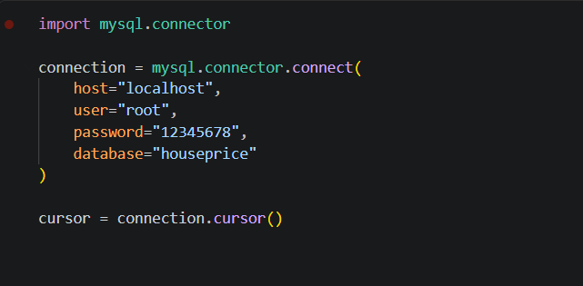
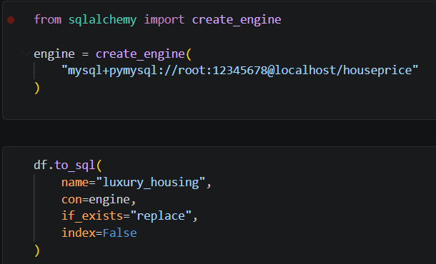
Run initial SQL validation queries:
SELECT * FROM houseprice.luxury_housing;

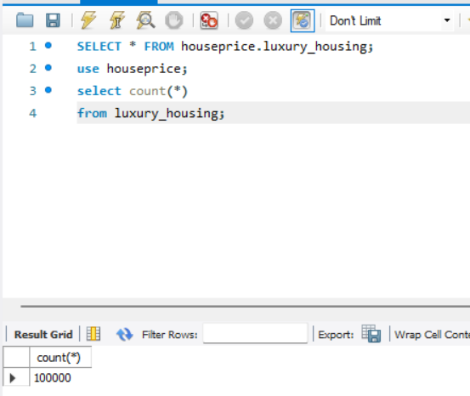
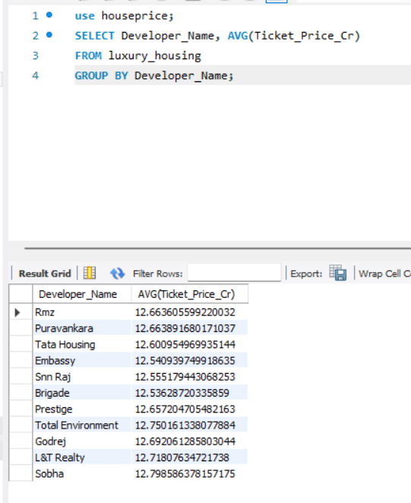

Data Visualization:
Power BI was used to create an interactive dashboard that visualizes trends, builder performance, market demand, and booking conversion patterns.

Power BI Dashboard
An interactive dashboard was developed in Power BI with a live connection to the SQL database.
The dashboard includes multiple visualizations that allow users to explore trends and patterns within the dataset.
Key dashboard features include:
- Interactive filters (Builder, Quarter, Micro Market)
- KPI indicators for important metrics (total ticket sales, booking counts, and conversion rates)
- Map visualization for geographic insights
- Charts for builder performance and booking trends

Key Business Insights
The analysis generated several insights relevant to the real estate market:

Market Trends
Luxury housing bookings vary across quarters and micro-markets, showing seasonal demand patterns. (Using Line chart)
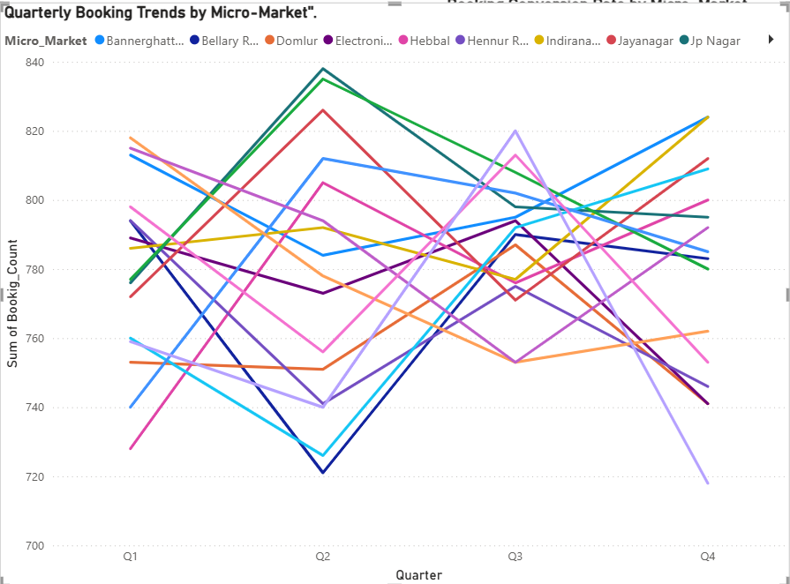

The line chart visualizes luxury housing bookings across different quarters and micro-markets. From the trend analysis, it becomes clear that booking activity fluctuates over time depending on market demand and seasonal trends. Certain micro-markets show consistent growth in bookings, indicating strong demand in those areas. Other micro-markets may show irregular booking patterns, suggesting varying buyer interest or project availability.
This visualization helps identify which locations are experiencing sustained growth and which require marketing or pricing adjustments.
Builder Performance
Some builders consistently achieve higher total ticket sales and maintain strong average ticket prices. (using Table)
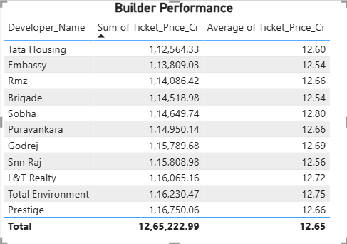
This highlights the difference between volume-driven builders and premium boutique builders. A builder might have the highest total sales because they sell many cheaper units, while another ranks highest in average ticket size because they sell ultra-luxury properties.
This visualization compares builders based on their total ticket sales and average ticket size. Builders with the highest total ticket sales contribute significantly to the overall market revenue. Meanwhile, the average ticket size highlights which builders focus on higher-value luxury properties. Builders with both high total sales and high average ticket values demonstrate strong market positioning and customer trust. This analysis helps stakeholders identify top performing builders and benchmark their performance.
Amenity Impact
Projects with higher amenity scores generally show better booking success rates, indicating that amenities significantly influence buyer decisions. (Using Scatter Plot)
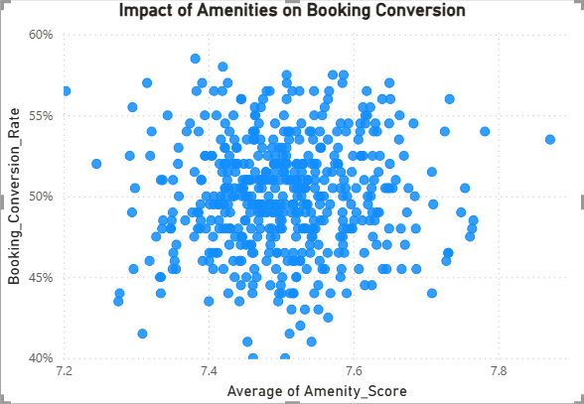
Booking Conversion
This visualization highlights booking conversion rates across different micro-markets. Some micro-markets demonstrate higher conversion rates, meaning a larger percentage of interested buyers finalize bookings. Other micro-markets show lower conversion rates, indicating potential issues such as pricing, competition, or limited buyer demand. Understanding these differences allows developers and sales teams to focus on markets where conversion improvement strategies are required.(Using 100% stacked column chart)

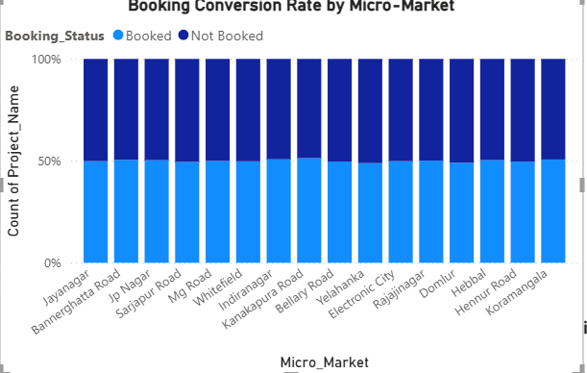

Configuration Demand
The donut chart illustrates the distribution of bookings across housing configurations such as 3BHK, 4BHK, or other layouts. The visualization clearly identifies which configuration type is most preferred by buyers. If a particular configuration dominates the chart, it indicates strong demand for that housing type. This insight helps developers plan future projects by prioritizing configurations that align with buyer preferences
Certain housing configurations such as 3BHK dominate the luxury housing segment.

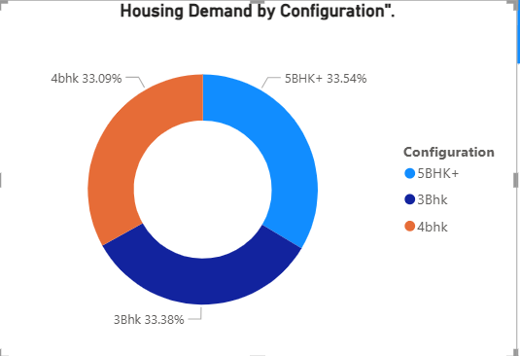

Sales Channel Effectiveness
Different sales channels contribute differently to booking success rates, highlighting the importance of marketing strategies. (Using 100% stacked column chart)

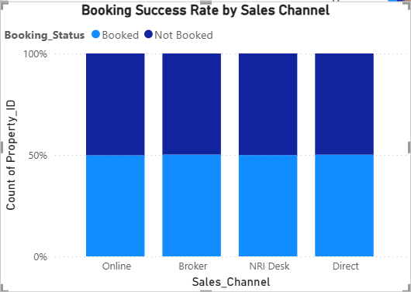
This tells the business where to invest their marketing budget by showing which method actually closes the deal.

Quarterly Builder Contribution:
This shows market share and dominance. It tells us if one builder owns the market year-round, or if different builders take the lead in different quarters based on project launch dates.

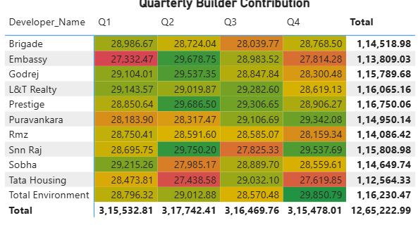
The matrix visualization compares builder contributions across different quarters based on ticket price values. Builders that consistently generate high sales across multiple quarters demonstrate strong market stability and project pipeline. Meanwhile, builders with irregular sales patterns may depend on specific project launches or seasonal demand. This analysis helps understand market dominance and builder competitiveness over time.
Possession Status Analysis:
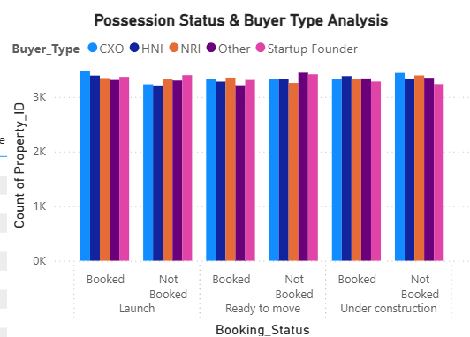
This clustered column chart evaluates how possession status influences booking decisions and buyer types. Projects that are ready for possession may attract buyers seeking immediate occupancy, while under-construction properties may appeal to investors or long-term buyers. The visualization also highlights whether specific buyer types prefer certain possession statuses, providing insights into customer behavior and investment patterns.
Geographical Insights
This visually maps out the "luxury hubs" of Bangalore, showing where developers are heavily investing in land and projects.
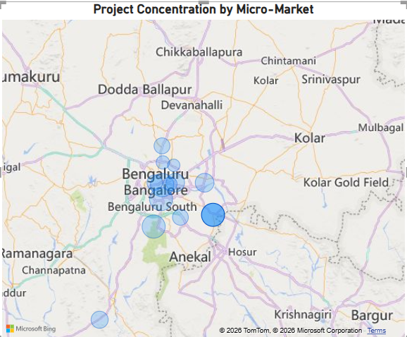
The map visualization identifies where luxury housing projects are concentrated within the city. Areas with a higher number of projects indicate major real estate development zones. These locations may benefit from strong infrastructure, accessibility, and lifestyle amenities. Understanding geographic concentration helps developers identify high-growth markets and plan expansion strategies accordingly.
Top Performers
This serves as the executive summary, definitively crowning the absolute leaders of the luxury real estate market in Bangalore based on hard revenue numbers.
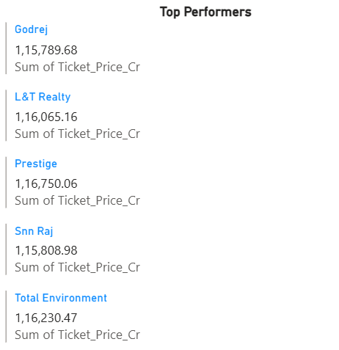
This visualization highlights the top builders based on revenue generation and booking success rates. Builders appearing in the top positions demonstrate strong sales performance and market credibility. Drill-through capabilities allow deeper analysis of their project portfolios and booking details. These insights help identify industry leaders and evaluate competitive benchmarks in the luxury housing market.

Business Recommendations
Based on the analysis, the following recommendations can help improve business decision-making:
- Developers should focus more on high-demand micro-markets where booking conversions are consistently strong.
- Builders should invest in high-quality amenities to increase project attractiveness and booking success.
- Future projects should prioritize popular housing configurations preferred by buyers.
- Marketing teams should allocate more resources to high-performing sales channels to improve conversion rates.
- Real estate companies should closely monitor market leaders to understand successful strategies and maintain competitiveness.

Tools and Technologies Used
The project demonstrates practical experience with the following technologies:
- Python – Data preprocessing and feature engineering
- MySQL – Data storage and querying
- Microsoft Power BI Desktop – Dashboard creation and visualization
- Git – Version control and project management

Results
The project successfully produced:
- A clean and structured SQL database containing normalized housing data
- A fully interactive Power BI dashboard connected directly to the SQL database
- Analytical insights that can support decision-making for real estate developers and investors
- Hands-on experience with an end-to-end data analytics workflow

Conclusion
This project demonstrates how data analytics can be applied to the real estate industry to uncover meaningful insights. By combining Python for data preprocessing, SQL for structured data storage, and Power BI for visualization, the project successfully builds a complete data pipeline.
The dashboard enables stakeholders to analyze builder performance, market demand, booking trends, and amenity impact. These insights can assist real estate firms in making data-driven decisions related to marketing strategies, project planning, and customer preferences.
Future improvements may include integrating larger datasets, implementing predictive analytics models, and enhancing dashboard interactivity.

